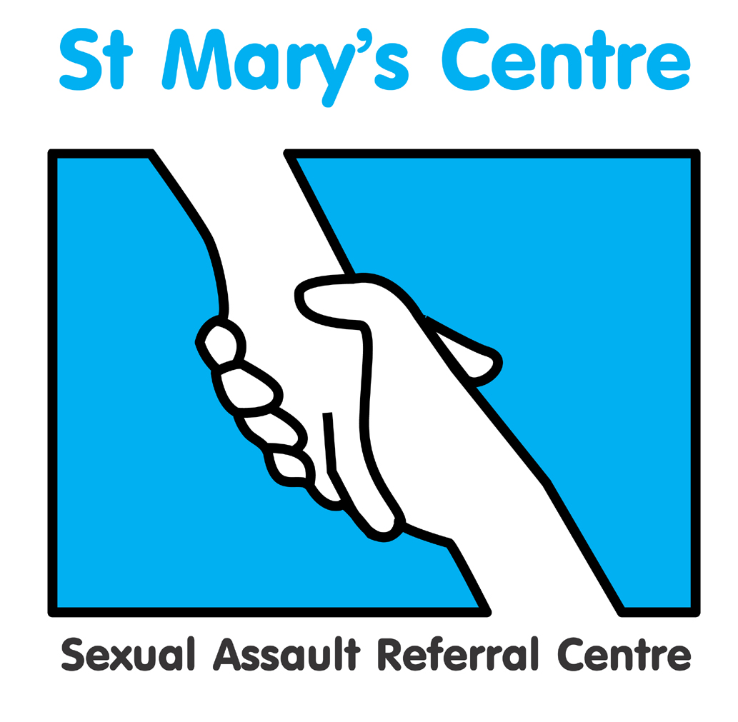

Principles of

Forensic and Medical Examination
for Rape and Sexual Assault

Course Guide for Unit One

2023 Dates:

January 17th, 18th & 19th

March 7th, 8th & 9th

Course Unit Leader: Dr. Cath White

Contents

Section | Topic | Page
1 | Course Unit Leader Contact Details | 3
2 | Introduction to the Course Unit | 3
3 | Course Unit Aims and Outcomes | 3
4 | Teaching/Learning hours and Methods for the Course Unit | 4
5 | Student Support During the Course Unit. | 4
6 | Assessment | 5-6
7 | Evaluation | 7
8 | Core Learning Materials | 8
1. Course Unit Leaders Contact Details

Name | Location | Telephone no’s | E-mail
Dr Cath White | Saint Mary’s Centre  Mobile | 0161 276 6515  07887 730 033 | catherine.white2@nhs.net

2. Introduction to the Course Unit

Welcome to Unit One of the Saint Mary’s Course – Principles of Forensic and Medical Examination for Rape and Sexual Assault. During this course unit you will be introduced to the medical skills, legal framework, support services and social context underlying the work of the forensic clinician. The course is delivered by practitioners who are expert in their fields, and serves as the prerequisite for Unit Two, Practice of Forensic and Medical Examination for Rape and Sexual Assault.

  - Content

- Overview of course programme
- Diversity of sexual assault
- History of sexual assault law
- Self harm and the psychological effects of rape
- Saint Mary’s Model for sexual assault referral centres
- Ethics
- Child protection overview
- Consent and capacity
- Anatomy overview
- Adult Forensic Medical Examination theory
- Injury classification theory
- Emergency Contraception, STI and PEP overview
- Forensic science overview
- Police investigation
- Legal (court) process
- Statement writing
- Genograms
- Child sexual exploitation
- The power of listening
- Sexual assault in the context of domestic abuse
- Anogenital findings after sexual assault
- Non-fatal strangulation

3. Course Unit Aims and Outcomes

  - Aims

This course unit aims to provide qualified healthcare professionals with in-depth knowledge and understanding of the context, theory and principles relevant to sexual offence medicine

Outcomes

3.2.1 Knowledge and Understanding

- Critically evaluate the nature and diversity of rape and sexual assault in the context of socio-cultural, historical and legal definitions
- Demonstrate an in-depth understanding of medico-legal and ethical frameworks and principles relevant to forensic and medical examination of sexual assaults
- Identify and critically examine appropriate professional responses in the investigation, treatment, management and prosecution of cases of sexual assault
- Demonstrate an in-depth knowledge of the anatomy and physiology relevant to this field

    - Intellectual Skills

  - Critically analyse literature and policy frameworks related to this field
  - Identify and critically evaluate relevant research recognising the inherent difficulties of research in this field
  - Demonstrate analytical thinking in discussion groups

3.2.3 Transferable Skills and Personal Qualities

- Participate in a group presentation
- Demonstrate effective written and verbal communication skills

4. Teaching/Learning Hours and Methods for the Course Unit

Activity | Hours allocated
Taught sessions | 40
Tutorial time | 2
Self-directed study | 158
Total hours | 200

Tutorial time may be one-to-one, group, face-to-face, virtual, telephone or email. Lectures will be mainly didactic, with audio-visual elements, interactive question and answer sessions, and use of anatomical models. Where possible they will be in person, but may need to be virtual dependent upon restrictions related to the pandemic.

  - Independent study

As you will see from the hours above, there is a considerable amount of time allocated to independent study. It is important that you organise yourself to undertake these additional hours as they are as important to your learning as direct teaching. This equates to approximately 14 hours per week from the start of the course to the deadline for the assessed essay. This time includes that spent observing forensic medical examinations and visiting relevant organisations, as well as preparation for the examination and essay.

5. Student Support during the Course Unit

  - Academic tutors

Each student will be allocated an academic tutor from the course teaching team who is available for academic support and advice during the unit of study. The Course Leader is also one of the academic tutors. The best way to arrange an appointment is by contacting your tutor in person during the course or via telephone or e-mail. Please remember that all teaching team members are also engaged in many other activities and therefore may not be available to see you immediately. It is preferable to contact them in advance to arrange a mutually agreeable appointment.

6. Assessment

Assessment activity | Length required | Weighting within unit
Unseen examination (07/03/2023)  Multiple choice and short answer questions on key subject areas covered in the unit. Students will be required to demonstrate, on the chosen questions, undertaken under controlled conditions, in-depth knowledge and understanding, critical evaluation and application to practice.  A minimum mark of 40% must be achieved for successful completion. This assessment is designed to meet learning outcomes: 1,2,3,4 | One hour | 50%
Short Answer Paper  Students are required to complete a written task on consent & capacity, details of which will be given in Block B  Candidates will be marked on inclusion of the key topics, literature, studies, and cases that should be mentioned and the school general assessment criteria for level 3 work.  Criteria of success are to: show an-depth knowledge and understanding of current policy, guidelines and debates; show evidence of critical appraisal, discussion and evaluation of the chosen topic; and an ability to integrate theory and practice.  A minimum mark of 40% must be achieved for successful completion. This assignment is designed to meet learning outcomes: 1,2,3,5,6,10 |  | 50%

Students are also required to attend a minimum of 80% of taught sessions and undertake observations and visits below. These observations and visits are an essential requirement for successful completion of the course unit, but are not assessed.

Observations of forensic medical examinations

Students will be expected to observe any five forensic medical examinations of sexual assault complainants from the start of the taught course. All examinations, if possible, shouldbe performed by an MFFLM qualified Forensic Clinician and a signed witness statement must be completed confirming the student’s presence, the examiner’s identity and the examination observed. A witness statement document is available from Saint Mary’s Centre. Please contact Josh Edgar, Course Administrator, at josh.edgar@mft.nhs.uk

  - Other suggested visits

To maximise your learning experience, students will be expected to make at least two visits to other services or events from the following list: All observations and visits should be completed and the signed witness statement documents to be submitted to Josh Edgar, Course Administrator, by Friday 18th August 2023.

- a rape trial at Crown Court
- a police force’s video interview suite
- a police force’s Scenes of Crime Team
- a Sexual Assault Referral Centre other than Saint Mary’s Centre or SAFEPlace
- another suitable service agreed by the Course Leader.

- A signed witness statement must be completed confirming the student’s presence, the contact person at the service visited, and the nature of the service visited.

  - Submission Date for Short Answer Paper

The short answer paper must be received in electronic form at St. Mary’s Centre by 12 noon on Friday 21st April 2023. Please send these to josh.edgar@mft.nhs.uk

Please provide essays in word format not PDF.

Please use font size 12, double line spacing and include a 4cm left hand margin to allow for marking/notes. Please submit your essays in word format and do not include your name in the title page.

Please note that failure to submit by the deadline will result in a mark of zero. If in exceptional cases you need an extension please contact Josh Edgar for an extension form.

You are strongly advised to retain a copy of written assignments and to ensure you obtain a receipt on submission. Receipt of the essay will be made by email to the address provided on the course application form. If you require notification of receipt by other means you must arrange for this with the Course Administrator, Josh Edgar at the Saint Mary’s Centre.

  - Draft work and guidance

Academic tutors will be available to provide guidance and advice on the essay as you are working on it. They will view one essay plan/outline with notes of up to 500 words providing it is received up to two weeks before the essay submission date. Tutors will not review full drafts.

7. Evaluation

We greatly value your feedback on this course and evaluation of all elements of course units is essential in order to reflect on your own learning, provide feedback on the strengths and potential areas for enhancement of the teaching and learning experience. The following methods of evaluation will be utilised:

- Anonymous structured questionnaires (quantitative)
- Group evaluations (qualitative)
This will take place at the end of teaching on the final day of the course

We will also provide completed feedback sheets on your performance at the end of each Module which will be shared with you for appraisals and with funders. This feedback sheet will be completed by your course tutor and will comprise a summary of Attendance, Achievement and Attitude.

Attendance - you are aware that the course consists of 4 modules, each of 3 days. You should expect to have teaching from 9-5pm each of those days. 100% attendance is expected, however if difficulties arise then a minimum of 80% attendance is required to complete the course successfully.

Achievement- this will include the marks for your examination, and for your 2 written assignments. It will also include a record of observed examinations and visits you have completed.

Attitude – we expect you to bring your own concerns and experiences and to engage with your fellow students and with the course. We realise that people have different learning styles, and some are naturally quieter or louder than others. However, we expect you to prioritise your time with us and be “present in the room” during all sessions.

We would ask that you minimise disruption during teaching sessions by not interacting with mobiles or electronic devices unless it directly supports your learning on the course. We do ensure frequent comfort breaks as part of the programme and expect all students to participate fully in group activities.

8. Core Learning Materials

  - Printed Resources

Clinical texts

Girardin, B.W., Faugno, D.K., Seneski, P.C., Slaughter, L., and Whelan, M. (1997) Color Atlas of Sexual Assault. St. Louis: Mosby
Miscellaneous

Heger, A. (2000) Evaluation of the Sexually Abused Child. Second Edition. Oxford: Oxford University Press.

Royal College of Paediatrics and Child Health in collaboration with Royal College of Physicians of London and its Faculty of Forensic and Legal Medicine (2015) The Physical Signs of Child Sexual Abuse: An evidence-based review and guidance for best practice. Terence Dalton Ltd. Physical signs of child sexual abuse - evidence-based review (currently under review, with next edition due in 2023)

Stark, MM. (2020 Clinical Forensic Medicine – A Physician’s Guide. Springer Nature, SwitzerlandISBN 9783030294649

White, C. (2010) Sexual Assault, A Forensic Physician’s Practice Guide. ISBN 978-0-9564737-0-7
Best Practice and Research. Clinical Obstetrics and Gyneacology, Clinical Aspects of Sexual Violence. Vol. 27 Number 1. February 2013 (ISSN 1521-6934)

Forensic Gynaecology Series: Royal College of Obstetricians and Gynaecologists Advanced Skills Edited by Maureen Dalton 2015 (ISBN-13: 9781107064294)
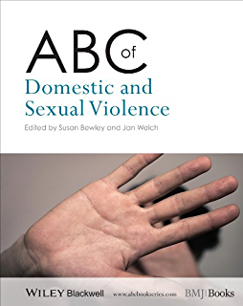

Law and Medical Ethics

Sexual Offences Act 2003. A Current Law Statute Guide Thomas JL. Sweet &
Maxwell. 2004 (ISBN 0421878304)

Mental Capacity Act Code of Practice Stationery Office. 2007 (ISBN 978 0 11
7037465)

Mental Health Act 1983 Code of Practice (2008 Edition), Stationery Office, 2008.
ISBN 978 0 11 3228096.

Mental Health Act Manual Jones, R. 11th Edition. Sweet & Maxwell. 2008 (ISBN
9781847034007)

Law and Medical Ethics 11th Edition. Mason & McCall Smith. Oxford University
Press, 2019 (ISBN 9780198826217

Principles of Biomedical Ethics.8th Edition. Beauchamp T L & Childress J F.
Oxford University Press (ISBN 13: 978-0190640873)

Key Guidance Publications

FFLM documents

www.fflm.ac.uk

GMC publications:

Good Medical Practice, 2019.
Decision making and consent 2020
Acting as a witness 2013
Personal beliefs and medical practice 2020
0-18 years: guidance for all doctors, 2018
Making and using visual and audio recordings of patients (2011)
Protecting children and young people: The responsibilities of all doctors (2018)
Confidentiality (2017)
Leadership and management for all doctors (2012)
Raising and acting on concerns about patient safety (2012)

Safeguarding

Responsibilities of doctors in Child Protection Cases with regard to
Confidentiality . February 2004. Royal College of Paediatrics and Child Health.
available at www.rcpch.ac.uk

Working Together to Safeguard Children: A guide to inter-agency working to safeguard and promote the welfare of children. 2018. Working Together to Safeguard Children 2018 (publishing.service.gov.uk)

RCPCH
Child protection resources – RCPCH Child Protection Portal

RCPCH Evidence & Reviews https://childprotection.rcpch.ac.uk/child-protection-evidence/

RCPCH . Child Protection Companion, Online document 2017 onwards Child Protection Companion – RCPCH Child Protection Portal (requires subscription)
Safeguarding Children and Young People: Roles and Competencies for Healthcare Staff | Royal College of Nursing (rcn.org.uk) The fourth edition of Safeguarding Children and Young People: Roles and Competences for Healthcare Staff was updated in 2019, led by the Royal College of Nursing (RCN). Updated in December 2021

Child protection service delivery standards 2020 Child protection service delivery standards – RCPCH Child Protection Portal

The Children’s Commissioner for the UK:
http://www.childrenscommissioner.gov.uk/

National Working Group on Child Sexual Exploitation
http://www.nwgnetwork.org/

Sexual Health

www.bashh.org

UK guideline for the use of HIV post‐exposure prophylaxis 2021 (bashhguidelines.org)
BASHH National Guideline on the Management of Sexually Transmitted Infections and Related Conditions in Children and Young People (2021) https://www.bashhguidelines.org/media/1294/children-and-yp-2021.pdf
The Management of Adult and Adolescent Complainants of Sexual Assault (bashhguidelines.org)
CHIVA http://www.chiva.org.uk/professionals/health/guidelines/pep/young-pep-ref.html
Post-Exposure Prophylaxis (PEP) guidelines for children and adolescents exposed to blood-borne viruses

Emergency contraception

FSRH Clinical Guideline: Emergency Contraception (March 2017, amended December 2020) - Faculty of Sexual and Reproductive Healthcare

FSRH Clinical Guideline: Contraceptive Choices for Young People (March 2010, amended May 2019) - Faculty of Sexual and Reproductive Healthcare

Miscellaneous

Please feel free to access Saint Mary’s papers at the following location:
https://www.stmaryscentre.org/professionals/research/publications

  - Internet Resources

American Journal of Forensic Medicine and Pathology
http://www.amjforensicmedicine.com

Forensic Science International http://www.sciencedirect.com/science/journal/03790738

Journal of Clinical Forensic Medicine http://www.harcourt-international.com/journals/jcfm

Journal of Forensic Nursing http://www.forensicnurse.org

Journal of Forensic Sciences http://www.blackwell-synergy.com/loi/jfo

Journal of Legal Medicine http://www.tandf.co.uk/journals/titles/01947648.asp

Violence Against Women
http://www.sagepub.co.uk/journalsProdDesc.nav?prodId=Journal200837

Diploma in the Forensic and Clinical Aspects of Sexual Assault (DFCASA)
http://fflm.ac.uk/education/
Examination for the Membership of the Faculty of Forensic and Legal Medicine (MFFLM)
http://fflm.ac.uk/education/mfflmexam/

Honour based crimes
http://www.safenetwork.org.uk

NHS England www.england.nhs.uk

